Welcome to the study!

The purpose of this research study, being conducted at the University of Pennsylvania, is to find out about a number of thoughts and beliefs that people often have, as well as judgments and personality characteristics.

The study is comprised of a set of questionnaires and puzzles that will take about 20 minutes to complete.

Your participation is entirely voluntary and your information is completely anonymous. We will not link any information with any participant.

This study presents little to no risks. If you have questions about your rights as a volunteer in this research study, you can contact the Office of Regulatory Affairs at the University of Pennsylvania at 215-898-2614.

In addition, you can contact us with any questions by e-mailing the principal investigator (Dianne L. Chambless) at chambless@psych.upenn.edu.

Please verify that you would like to participate.

--------------------------
Signature

Your 10-digit Penn ID: 
Directions: We are interested in studying the association between handwriting and personality.
Please copy the following paragraph.

Two years ago, when I was a junior partner at a prestigious law firm, I was coming up for promotion against another junior partner, Chris. For several months, Chris had been working on a major case for the city that would make or break his career at the firm. However, he could not locate a key zoning document, without which, it was unlikely that he would have sufficient evidence to successfully argue his case. Late one evening, as I was rummaging through a corner filing cabinet, I happened to come across the zoning document that Chris was in desperate need of. I pulled it from the cabinet and walked over to the office shredder, knowing that my promotion would now be secured.

Directions: We are interested in studying the association between handwriting and personality.
Please copy the following paragraph.

Two years ago, when I was a junior partner at a prestigious law firm, I was coming up for promotion against another junior partner, Chris. For several months, Chris had been working on a major case for the city that would make or break his career at the firm. However, he could not locate a key zoning document, without which, it was unlikely that he would have sufficient evidence to successfully argue his case. Late one evening, as I was rummaging through a corner filing cabinet, I happened to come across the zoning document that Chris was in desperate need of. I said nothing about what I found, hoping that my promotion would be secured.

Directions: We are interested in studying the association between handwriting and personality.
Please copy the following paragraph.

Two years ago, when I was a junior partner at a prestigious law firm, I was coming up for promotion against another junior partner, Chris. For several months, Chris had been working on a major case for the city that would make or break his career at the firm. However, he could not locate a key zoning document, without which, it was unlikely that he would have sufficient evidence to successfully argue his case. Late one evening, as I was rummaging through a corner filing cabinet, I happened to come across the zoning document that Chris was in desperate need of. I pulled it from the cabinet and placed it without a note on Chris’ desk, knowing that he would be so relieved when he arrived to work the next morning.

Directions: Following is a short game, in the style of hangman and crossword puzzles.
Before moving on to the next part of the questionnaire, please complete these words.

SP

TP

S HR

T HE

WH

HD

Directions: Please rate the desirability of these common products.

1------------2------------3------------4------------5------------6------------7
completely neither desirable completely undesirable nor undesirable desirable

Lysol disinfectant 1 2 3 4 5 6 7

Nantucket Nectars juice 1 2 3 4 5 6 7

Dove shower soap 1 2 3 4 5 6 7

Energizer batteries 1 2 3 4 5 6 7

Crest toothpaste 1 2 3 4 5 6 7

Post-it Notes 1 2 3 4 5 6 7

Tide detergent 1 2 3 4 5 6 7

Snickers bars 1 2 3 4 5 6 7

Windex cleaner 1 2 3 4 5 6 7

Sony CD cases 1 2 3 4 5 6 7

Watson, Clark, & Tellegen (1988):

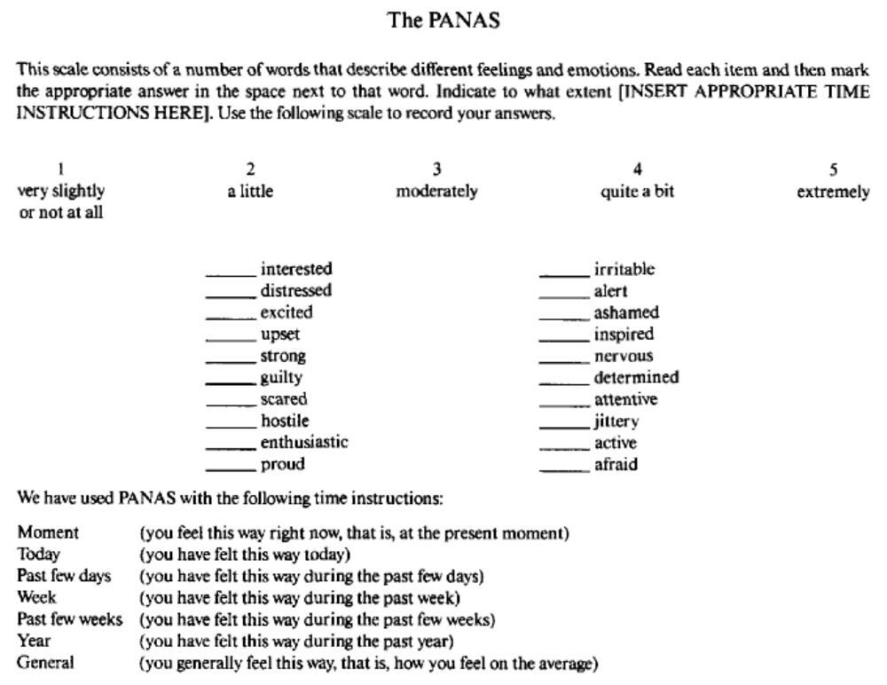

Foa et al., 2002:

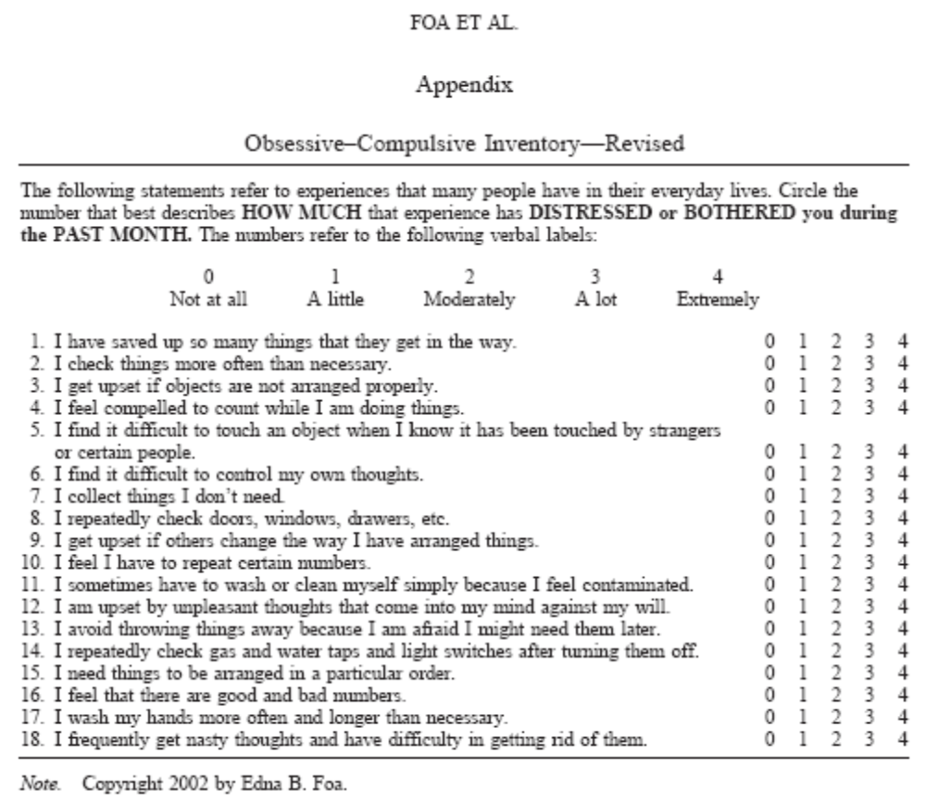

Please indicate your religious affiliation. If yours is not listed, please select “other,” and write in your religious group.
Catholic; Protestant; Jewish; Muslim; Hindu; No religion; Other (please specify)_______

Abramowitz, Huppert, Cohen, Tolin, & Cahill (2002):

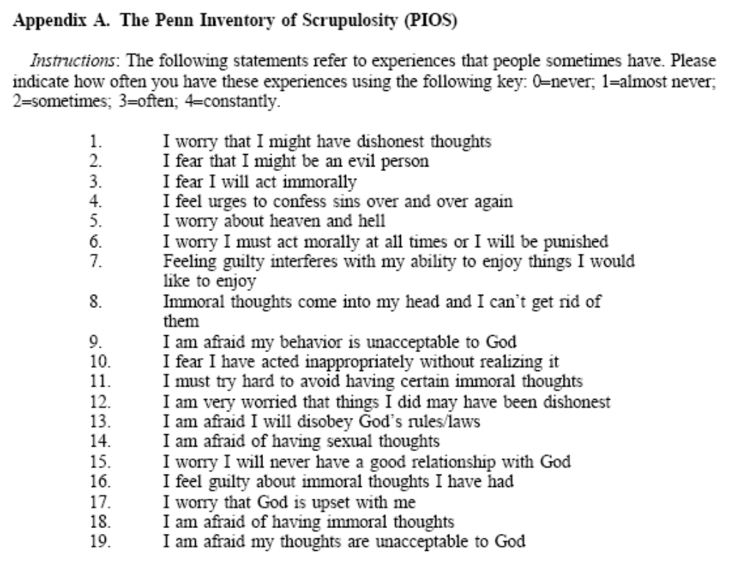
Shafran, Thordarson, & Rachman (1996) – Thought-Action Fusion Scale

Do you disagree or agree with the following statements? (5 point scale)

1. Thinking of making an extremely critical remark to a friend is almost as unacceptable to me as actually saying it.
2. Having a blasphemous thought is almost as sinful to me as a blasphemous action.
3. Thinking about swearing at someone else is almost as unacceptable to me as actually swearing.
4. When I have a nasty thought about someone else, it is almost as bad as carrying out a nasty action.
5. Having violent thoughts is almost as unacceptable to me as violent acts.
6. When I think about making an obscene remark or gesture in church, it is almost as sinful as actually doing it.
7. If I wish harm on someone, it is almost as bad as doing harm.
8. If I think about making an obscene gesture to someone else, it is almost as bad as doing it.
9. When I think unkindly about a friend, it is almost as disloyal as doing an unkind act.
10. If I have a jealous thought, it is almost the same as making a jealous remark.
11. Thinking of cheating in a personal relationship is almost as immoral to me as actually cheating.
12. Having obscene thoughts in a church is unacceptable to me.

1. If I think of a relative/friend losing their job, this increases the risk that they will lose their job.
2. If I think of a relative/friend being in a car accident, this increases the risk that he/she will have a car accident.
3. If I think of a friend/relative being injured in a fall, this increases the risk that he/she will have a fall and be injured.
4. If I think of a relative/friend falling ill this increases the risk that he/she will fall ill.

1. If I think of myself being injured in a fall, this increases the risk that I will have a fall and be injured.
2. If I think of myself being in a car accident, this increases the risk that I will have a car accident.
3. If I think of myself falling ill, this increases the risk that I will fall ill.
Responsibility Attitude Scale (Salkovskis et al., 2000)

This questionnaire lists different attitudes or beliefs which people sometimes hold. Read each statement carefully and decide how much you agree or disagree with it.
For each of the attitudes, show your answer by marking the words which best describe how you think. Because people are different, there is no right answer or wrong answer to these statements.
To decide whether a given attitude is typical of your way of looking at things, simply keep in mind what you are like most of the time. (7 point scale)
1. I often feel responsible for things which go wrong.
2. If I don't act when I can foresee danger, then I am to blame for any consequences if it happens.
3. I am too sensitive to feeling responsible for things going wrong.
4. If I think bad things, this is as bad as doing bad things.
5. I worry a great deal about the effects of things which I do or don't do.
6. To me, not acting to prevent disaster is as bad as making disaster happen.
7. If I know that harm is possible, I should always try to prevent it, however unlikely it seems.
8. I must always think through the consequences of even the smallest actions.
9. I often take responsibility for things which other people don't think are my fault.
10. Everything I do can cause serious problems.
11. I am often close to causing harm.
12. I must protect others from harm.
13. I should never cause even the slightest harm to others.
14. I will be condemned for my actions.
15. If I can have even a slight influence on things going wrong, then I must act to prevent it.
16. To me, not acting where disaster is a slight possibility is as bad as making that disaster happen.
17. For me, even slight carelessness is inexcusable when it might affect other people.
18. In all kinds of daily situations, my inactivity can cause as much harm as deliberate bad intentions.
19. Even if harm is a very unlikely possibility, I should always try to prevent it at any cost.
20. Once I think it is possible that I have caused harm, I can't forgive myself.
21. Many of my past actions have been intended to prevent harm to others.
22. I have to make sure other people are protected from all of the consequences of things I do.
23. Other people should not rely on my judgment.
24. If I cannot be certain I am blameless, I feel that I am to blame.
25. If I take sufficient care then I can prevent any harmful accidents.
26. I often think that bad things will happen if I am not careful enough.
Directions: Before submitting the survey, please provide the following information about yourself. Remember the questionnaire is anonymous.

1. Your gender: M F

2. Your age: _____ years-old

1------------2------------3------------4------------5
Not at All Extremely/Deeply
3. How religious are you? 1 2 3 4 5

4. How spiritual are you? 1 2 3 4 5

5. To what extent do you practice the 1 2 3 4 5
requirements of your religion or faith?

6. To what extent do you believe in the 1 2 3 4 5
teachings of your religion or faith?

7. How important a part of identity would 1 2 3 4 5
you say your religion or faith is to you?

8. If someone wanted to understand who 1 2 3 4 5
you are as a person, how important
would your religion or faith be in that?

9. What is your ethnicity?

__ Hispanic or Latino/a __ Not Hispanic or Latino/a

10. What is your race?

__Asian __ Asian-American __ American Indian or Alaskan Native

__ Black or African-American __ Native Hawaiian or other Pacific Islander

__ White __ Other:_______________

11. Your level of education:

__ Elementary school __ High school __ Some college

__ College degree __ Graduate degree

What was the purpose in this study of completing the words in the style of hangman or crossword puzzles?

What was the purpose in this study of ranking common household products?

Thank you for participating in this anonymous study!

We would like to share with you some background about this project. The primary purpose of this study is to examine the relationship between certain judgment and decision making tendencies and obsessive symptoms and cognitions. Specifically, omission bias refers to the tendency for people to prefer passive responsibility for a bad outcome instead of active responsibility for a less-bad outcome of the same type. Individuals with obsessive symptoms and cognitions are often characterized as having an inflated sense of responsibility and a tendency to view thoughts and intentions as morally equivalent to behavior. It is therefore hypothesized that increases in obsessive symptoms and cognitions will be associated with decreases in the tendency to exhibit omission bias. Among other things, we are therefore interested in your reactions to copying a scenario about someone’s moral behavior.

We will see what the data say...

If you feel that this study has raised for you any mental health related issues for which you require assistance, please call the Counseling and Psychological Service (CAPS) at 215-898-7021.

We are grateful for your assistance in this project - thanks!

p.s. Feel free to contact the principal investigator at chambless@psych.upenn.edu

